Pacific Canbriam Energy LTD
Production Update System
User Guide
Document Version 2.1 | June 2026
Audience: Reservoir Engineering Team

Table of Contents
Table of Contents 2
1. Introduction & executive summary 4
2. Before You Start 7
Prerequisites 7
Configuration Files 7
Running the Application 8
Information Icons 8
3. How Data Fits Together 9
Main Tables 9
Core Data Flow 9
4. Main Window Overview 10
5. Keeping Everything Up to Date 13
Prodview: Routine Update vs Full Rebuild 13
Prodview 2-Day Lag 14
After Adding New Wells 14
Month-Close Sequence 14
6. Module Guides 16
6.1 Well Master List 16
Opening vs Refresh 16
Save and Background Work 16
Additional Fields 16
Common Mistakes 17
6.2 Prodview / Snowflake — Daily Production Retrieve 17
Well Master Propagation on Prodview 17
Modes 18
Common Mistakes 18
6.3 ValNav Monthly Update (Sales + NGL) 18
NGL Flow (Monthly) 19
Common Mistakes 19
6.4 Public Sales Data and Ratios 20
Common Mistakes 20
6.5 Survey Data Import 20
Common Mistakes 21
6.6 Type Curves Import 21
6.7 Monthly Forecasts Import 22
Common Mistakes 23
6.8 Whitson+ Mass Upload 23
Push Production 23
Push Production 24
Common Mistakes 24
6.9 Exports / Reports 24
7. Monthly Runbook Checklist 26
8. Troubleshooting 27
9. Glossary 28
Appendix A — Screenshot Checklist 29
Appendix B — Building the Windows Executable (IT) 30

1. Introduction & executive summary
The Pacific Cambrian production system remains isolated; it primarily relies on a cloud- and web-based application named ProdView. Although this application is powerful and the central production data repository, it is limited in reporting, data extraction, and practical visualization.
The complexity of ProdView makes the production DCA, RTA, Numerical simulation and Nodal single- and multiwell analyses impractical for RE and other engineers in the company. In addition, Pacific Canbriam uses the PA team's production accounting (PA) allocation rates and volumes. The integrated information is gas, condensate, and NGL (C2, C3, C4, C5) production. Moreover, all this information is used for the month-to-month forecast, which is an additional process. Finally, there is the type curves integration. All these processes have been based on spreadsheets since Canbriam's establishment.
PCE has reached the overflow spreadsheet capacity, and the creation of an integration application with a client/server, entity relational database in SQL Server has been designed and implemented with the specific PCE needs that include the update to the primary reservoir engineering application, such as Harmony, Whitson+, Spotfire, Kappa Engineering, and Value Navigator. Figure 1 shows the replaced system with the RE Production System. Figure 2 shows the newly implemented system.
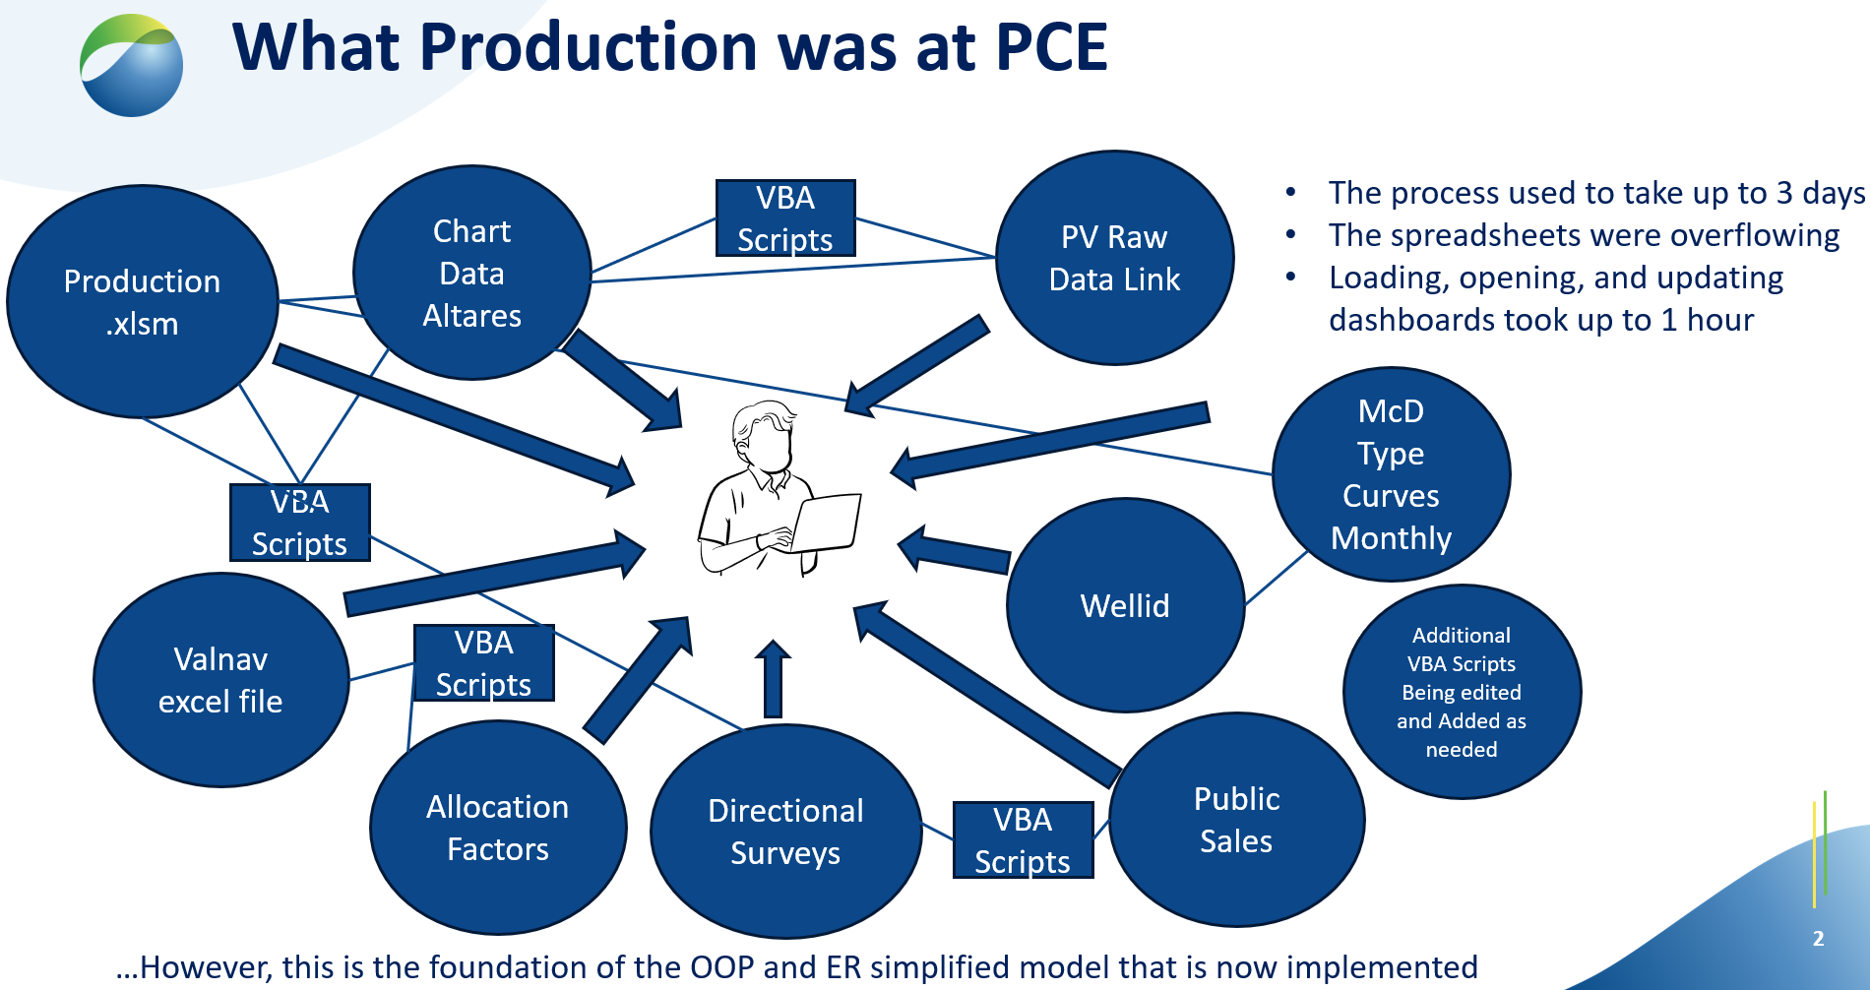
Figure 1. Existing and replaced production system integration diagram.
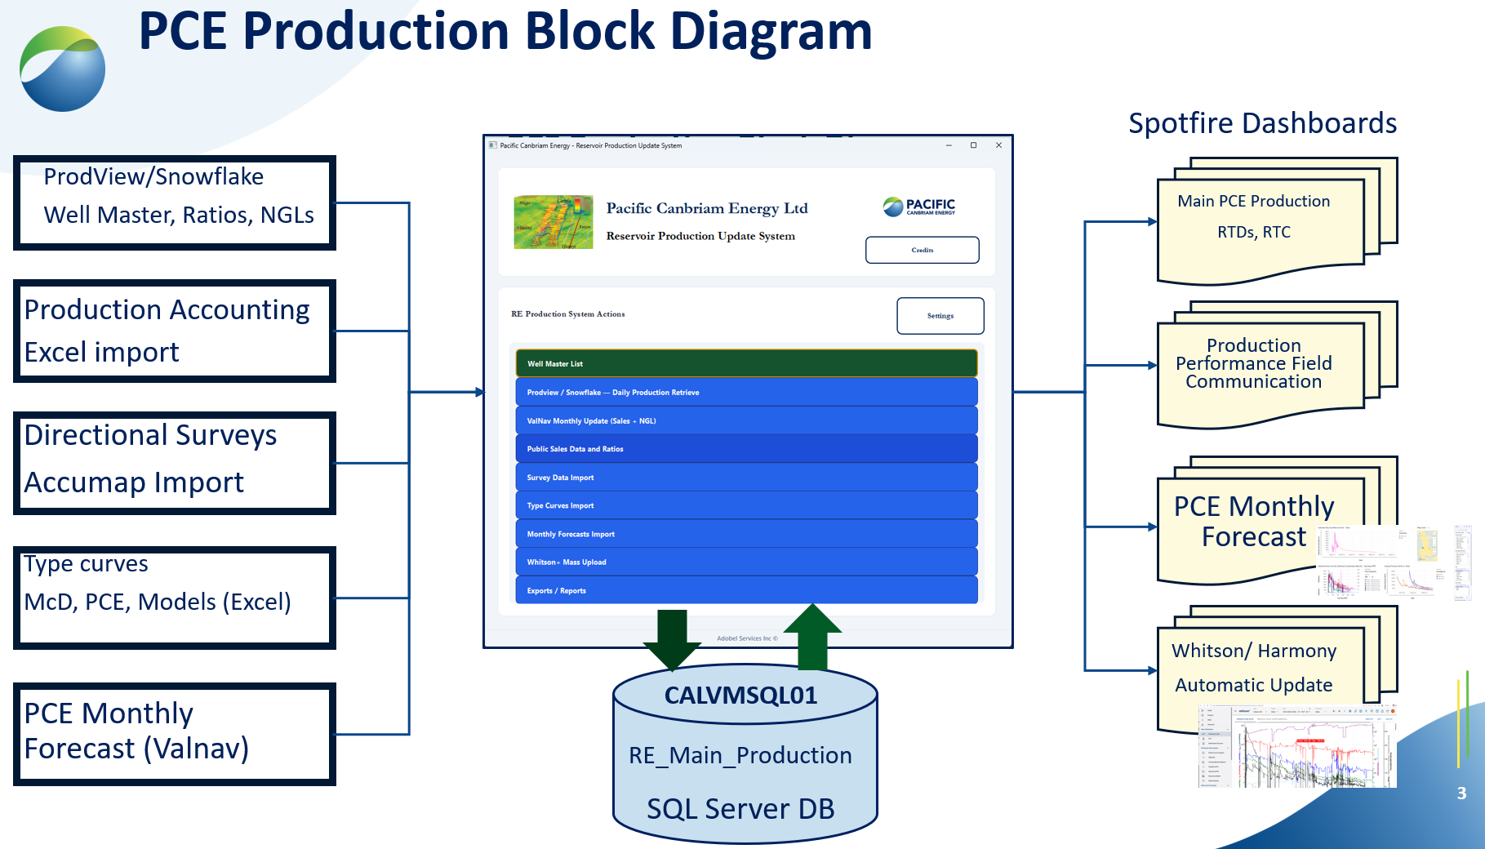
Figure 2. New RE Production System

The Production Update System is a desktop application used at Pacific Canbriam Energy to keep reservoir and production reporting data up to date. It connects to:
- SQL Server — stores well master, daily production, allocations, surveys, type curves, and forecasts
- ProdView/Snowflake — daily meter and allocation source data
- Excel workbooks — ValNav, Accumap, surveys, type curves, and monthly forecasts
- Whitson+ — optional push of production history to the reservoir modelling platform
- Harmony — optional push of production history to the reservoir modelling platform
- Spotfire — optional push of production history for production visualization
- Topaz — optional push of production history for exclusive RTA modelling
- Petrel — optional push of production history to the reservoir and frac modelling
When you launch the application, you are prompted for an application password before the main window opens. Contact your team lead if you need access.
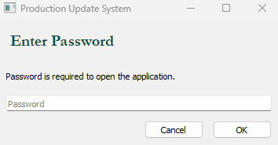

From the main window you can perform the following operations:

# | Operation
1 | Well Master List
2 | Prodview / Snowflake — Daily Production Retrieve
3 | ValNav Monthly Update (Sales + NGL)
4 | Public Sales Data and Ratios
5 | Survey Data Import
6 | Type Curves Import
7 | Monthly Forecasts Import
8 | Exports / Reports
9 | Whitson+ Mass Upload

Settings (SQL server, database, file paths) can be accessed from the RE Production System Actions panel header. Credits opens engineering and design credits. The footer shows vendor attribution.

2. Before You Start

Prerequisites
- Windows PC on the company network
- Access to the SQL Server database (Windows authentication)
- Snowflake / Prodview access when running daily production refresh or importing new wells (VPN may be required — confirm with IT)
- ODBC Driver 17 or 18 for SQL Server installed
- Application folder containing settings.ini and .env files (see Configuration Files below)

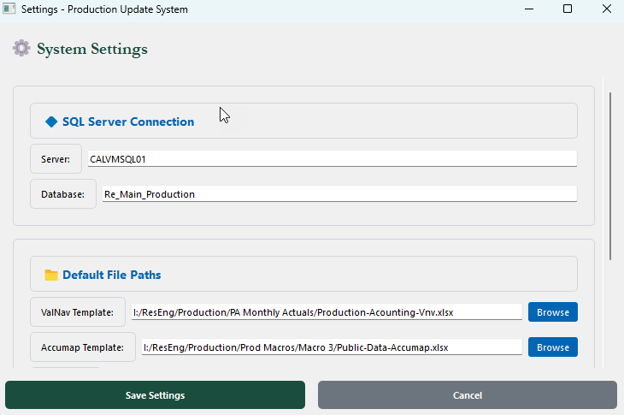

Configuration Files
File | Purpose
settings.ini | [SQL] server/database; [WHITSON] client, client_id, client_secret, project_id; [PATHS] to ValNav, Accumap, Survey, Type Curves, Whitson, and Monthly Forecasts workbooks
.env | Snowflake account, user, password, warehouse, database, schema, role; optional SQL overrides
settings.ini.example | Template for new installations
.env.example | Template for Snowflake and SQL variable names
whitson_imperial.ini | Metric-to-imperial conversion factors for Whitson+ production push (shipped with the application)

Running the Application
Deployed build: Run PCE_RE_Production_Update VX.X.exe from the folder that includes _internal, images, settings.ini, whitson_imperial.ini, survey_mapping_presets.json, and .env.

From source (developers / IT):
- Open the project folder in VSCode
- Create a virtual environment and select it as the Python interpreter
- Run: pip install -r requirements.txt
- Copy settings.ini.example to settings.ini and .env.example to .env; fill in real values
- Run production_update_gui.py (Run Python File or integrated terminal)

Information Icons
Information Icons are used to provide additional information to users about specific processes and procedures.

3. How Data Fits Together
Think of PCE_WM (Well Master) as the central hub. Every well that receives daily production or monthly allocations must exist here with the correct Well Name and Snowflake identifiers (GasIDREC, PressuresIDREC).

Main Tables
Table | What It Holds
PCE_WM | Well list: names, UWI, pad, formation, Enersight name, Snowflake IDs, exception flag
PCE_CDA | Daily production rows from Snowflake (wellhead rates, gathered rates, pressures, allocation-painted sales columns)
PCE_Production | Reporting history built from CDA: sequences, cumulatives, monthly averages, NGL ratios, sales columns
Allocation_Factors | Monthly allocation inputs — ValNav (PA), NGL, and Accumap (Public Sales); includes UWI and monthly NGL volumes
PCE_Surveys | Directional survey stations (MD, TVD, east/north, etc.)
PCE_TC | Type-curve metrics imported from Excel
PCE_Monthly_Forecasts | Monthly forecast rows from the forecasts workbook
PCE_FRCST_PRD | Combined reporting table: all forecasts plus gathered daily production (for charts/exports)

Core Data Flow
Snowflake daily data flows through the system in sequence:
Snowflake → PCE_CDA → PCE_Production

Monthly Excel files update Allocation_Factors, which then paint sales-related and NGL ratio columns onto PCE_CDA and PCE_Production.

The table below shows which module updates which sales columns on PCE_CDA and PCE_Production:

Source | Module | What It Updates on CDA / Production
ValNav | ValNav Monthly Update (Sales + NGL) | S2 gas production, condensate sales; monthly NGL ratio columns on Production
Accumap | Public Sales Data and Ratios | Gas sales production, sales CGR (and syncs all four sales columns on Production from CDA)

Important: PA and Public Sales are not interchangeable. Run both when you need a complete sales picture for a month.
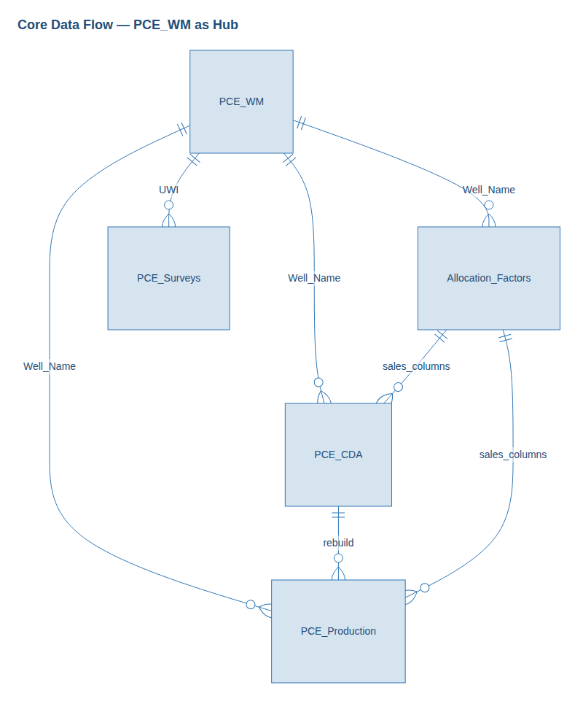
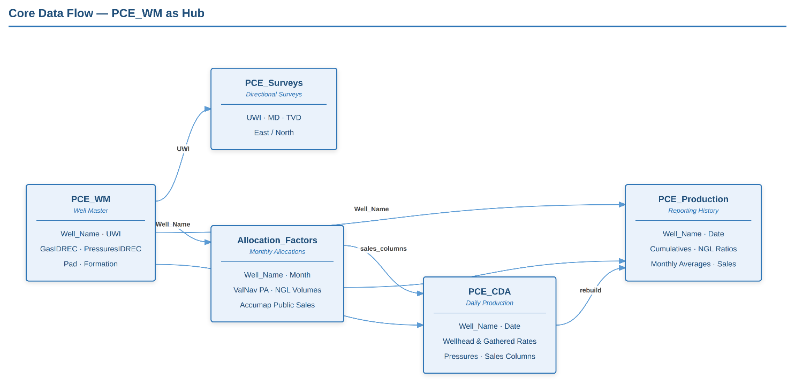

The diagram below shows how forecast and reporting tables relate:
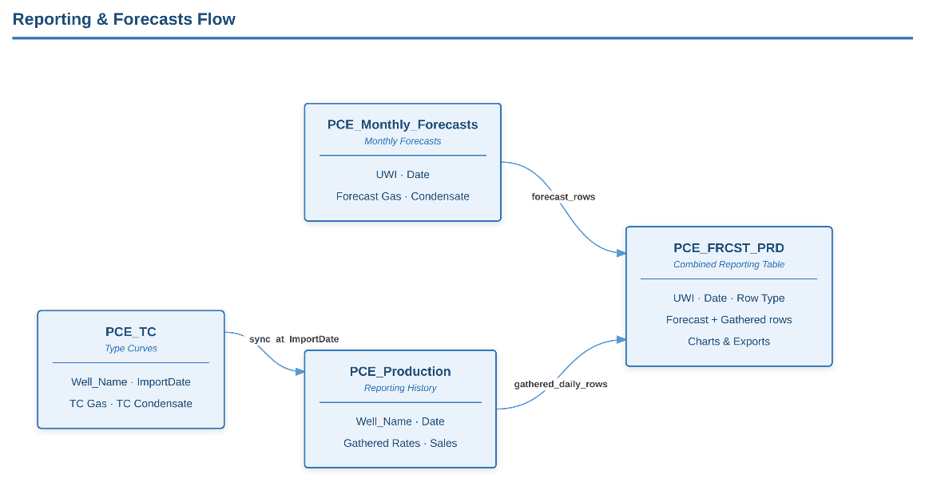

4. Main Window Overview
The main window title is Pacific Canbriam Energy - Reservoir Production Update System. The header shows the company logo, Credits, and a card with the application name. Below that, the RE Production System Actions panel lists nine operation buttons and Settings in the panel header row.

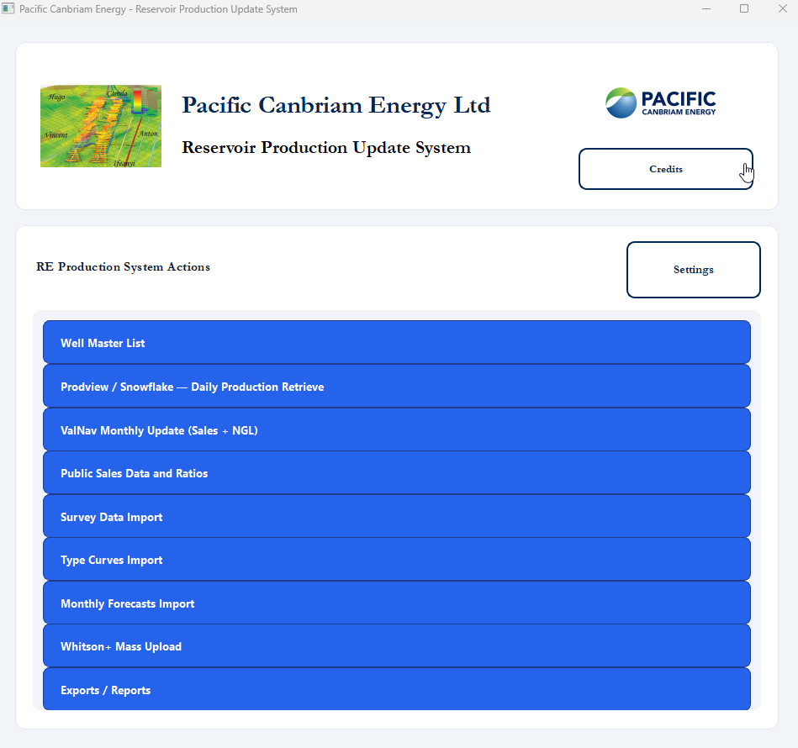
Buttons are arranged top to bottom in the following order:
- Well Master List
- Prodview / Snowflake — Daily Production Retrieve
- ValNav Monthly Update (Sales + NGL)
- Public Sales Data and Ratios
- Survey Data Import
- Type Curves Import
- Monthly Forecasts Import
- Exports / Reports
- Whitson+ Mass Upload

Each button opens a dedicated dialog. Long-running jobs display a progress indicator and a log within that dialog.

5. Keeping Everything Up to Date
The recommended order for running updates is:
Settings → Well Master → Prodview → ValNav (PA) → Public Sales → [optional imports] → Exports / Whitson+
Note: Confirm the exact refresh cadence (daily vs weekly Prodview) with your reservoir engineering team.

Step | When to Run | What Gets Updated
Well Master | New wells, name/UWI/pad changes | PCE_WM only — does not load production by itself
Prodview routine update | Routine refresh (often each business day) | Snowflake → PCE_CDA (~18-month window) → rebuild PCE_Production → PCE_FRCST_PRD
Prodview full rebuild | Serious data problems, full realignment or new wells added to database | All CDA history → full PCE_Production rebuild
ValNav (PA) | Monthly ValNav file is ready | Allocation_Factors (S2/cond/NGL from ValNav sheet, all PCE_WM wells), sales apply; daily NGL ratios on Production
Public Sales | Accumap file is ready | Gas sales and sales CGR for month range
Surveys / Type Curves / Forecasts | When those Excel files change | Respective tables; forecasts and Prodview also refresh PCE_FRCST_PRD
Whitson+ | When reservoir model needs latest production | Reads PCE_Production; pushes to Whitson API (no SQL table changes)

Prodview: Routine Update vs Full Rebuild
 | Routine Update | Full Rebuild (default)
Dialog label | Routine update — Snowflake → CDA + production (~12 months) | Full rebuild — PCE_Production from all PCE_CDA
Typical time | ~20 minutes | 40+ minutes on large history
Snowflake scope | ~12 calendar months rolling window | Full history per well (first production through today − 2)
Use when | When new production data is needed quickly. | After major fixes,new wells have been added to DB, and for scheduled rebuilds.
Also rebuilds | PCE_FRCST_PRD (NGL, UWI, pad, and type-curve sync preserved) | PCE_FRCST_PRD (same post-rebuild steps)

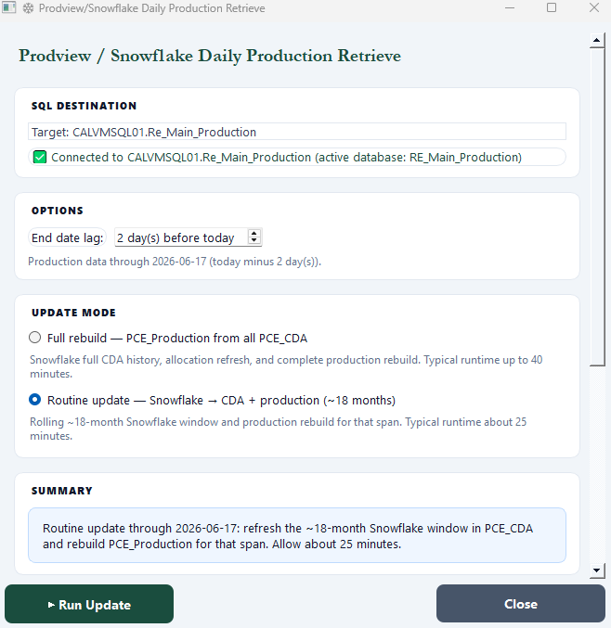

Prodview 2-Day Lag
Production is only loaded through today minus 2 days. Very recent days may appear blank until Prodview data is complete. This is intentional and matches the same rule used in forecast gathered slices and exports. There is an option to change the length of this lag.

After Adding New Wells
- Step 1: Import or edit the well in Well Master (including Snowflake IDs).
- Step 2: Run Prodview (routine update will work if well was added with the last year) so PCE_CDA and PCE_Production populate.
- Step 3: When monthly files are ready, run ValNav and Public Sales for affected months.

Important: Skipping Step 2 is a common reason new wells show no production.

Month-Close Sequence
- Confirm Prodview has run through the effective end date
- Run ValNav Monthly Update for that month (loads S2/cond/NGL into AF and applies daily NGL ratios)
- Run Public Sales for the same month range (dialog reminds you to run PA first)
- Import Monthly Forecasts or Type Curves if those files were updated
- Run Exports or Whitson+ if needed for reporting or modelling

6. Module Guides

6.1 Well Master List
Attribute | Detail
When to run | Adding wells, fixing well names/UWI/pad metadata, reviewing the active well list, importing new wells from Snowflake
What changes | PCE_WM. Removing a well can also purge its rows from PCE_CDA, PCE_Production, Allocation_Factors, and PCE_Surveys (confirm prompts)
Typical duration | Seconds to a few minutes depending on action

Opening vs Refresh
When you first open Well Master, the application loads wells from the database without recomputing Composite Name (faster startup). Click Refresh to reload from the database and recompute Composite Name from Well Name, Layer Producer, Completions Technology, and Orientation for all active wells.

Save and Background Work
Save, staged updates, and database reloads run on background workers so the dialog stays responsive. Toolbar buttons (Save, Refresh, Export, Import, Remove) are disabled while a load or save is in progress.

Additional Fields
Scroll to the rightmost ‘Additional Fields’ column and click “Fields…” on a checked well to edit coordinates, UTM, elevations, tubing, and dates. Surface and bottom hole lat/long are pushed to Whitson+ on the next mass upload.
Staging and Adding a New Well
- Select the new well(s) using the check box on the left-hand side, new wells are highlighted in yellow and are identified as “pending”.
- Once wells are selected press the “Stage” button to move them the pending wells to the “Add New Wells” table.
- Once in the “Add New Wells” table, the user should enter all required information before updating the selected wells, which automatically updates the SQL DB
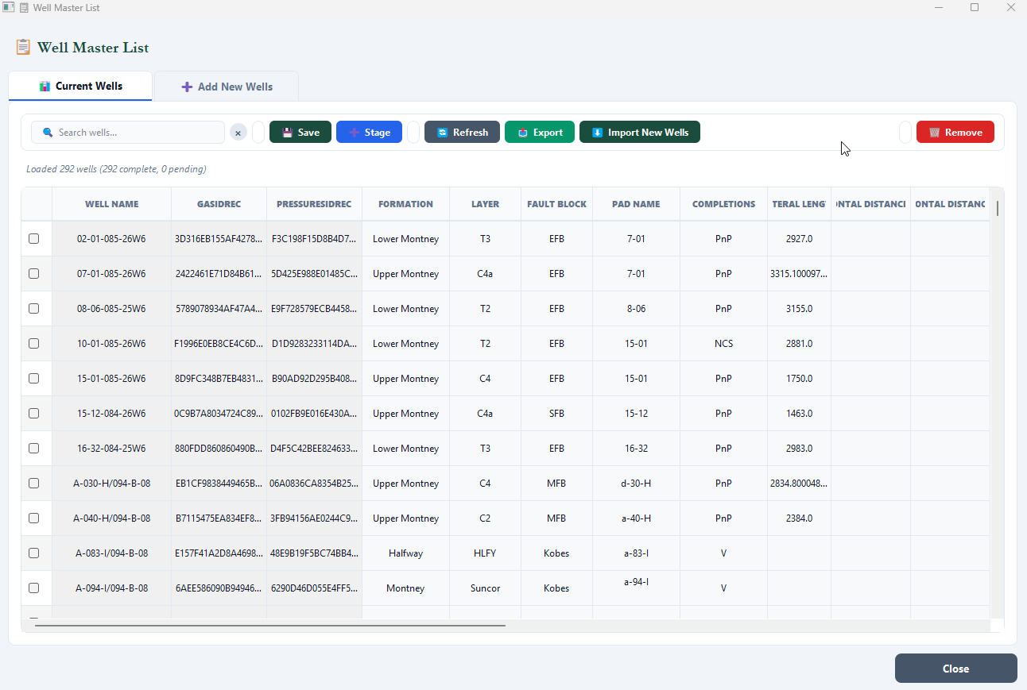

Common Mistakes
- Expecting production to appear immediately after WM import — run Prodview next
- Mismatched Well Name between WM and Snowflake — daily load may skip the well

6.2 Prodview / Snowflake — Daily Production Retrieve
Attribute | Detail
When to run | Routine production refresh; after Well Master changes; when CDA/Production look stale
What changes | PCE_CDA, PCE_Production, type-curve sync to production, PCE_FRCST_PRD
Typical duration | 5–20+ minutes

Well Master Propagation on Prodview
After each routine update or full rebuild, PCE_WM is the source of truth for production metadata. [UWI] is written on every new production row at insert time (from WM) and refreshed again from WM before NGL ratios run. [Pad Name] on gathered production is WM pad plus ' PRD' (e.g. '15-12 PRD') so forecast pads in PCE_FRCST_PRD stay distinct. Allocation_Factors.[UWI] is also aligned to WM on rebuild.

Modes
- Routine update — Snowflake → CDA + production (~12 months): Default mode; approximately 20 minutes
- Full rebuild — PCE_Production from all PCE_CDA: Heavy operation; 40+ minutes

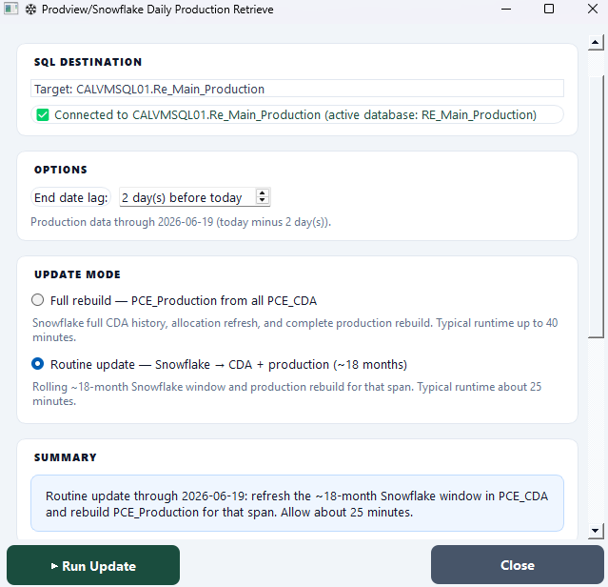

Common Mistakes
- Using full rebuild for routine updates (unnecessary load on SQL and Snowflake)
- Running ValNav/Public Sales before Prodview when daily wellhead data is missing

6.3 ValNav Monthly Update (Sales + NGL)
Attribute | Detail
When to run | When the monthly ValNav workbook is finalised for a given month
What changes | Allocation_Factors (UWI, ValNav columns, NGL volumes), PCE_CDA and PCE_Production (S2 gas, condensate sales), daily NGL ratio columns on PCE_Production
Typical duration | A few minutes per month

NGL Flow (Monthly)
- In the GUI, select the month and click Run Monthly Loader. The system reads NGL-C2, NGL-C3, NGL-C4, NGL-C5, and NGLs from the ValNav worksheet, writes them to Allocation_Factors, then applies daily NGL ratio columns to PCE_Production via PCE_NGL_Daily_Staging

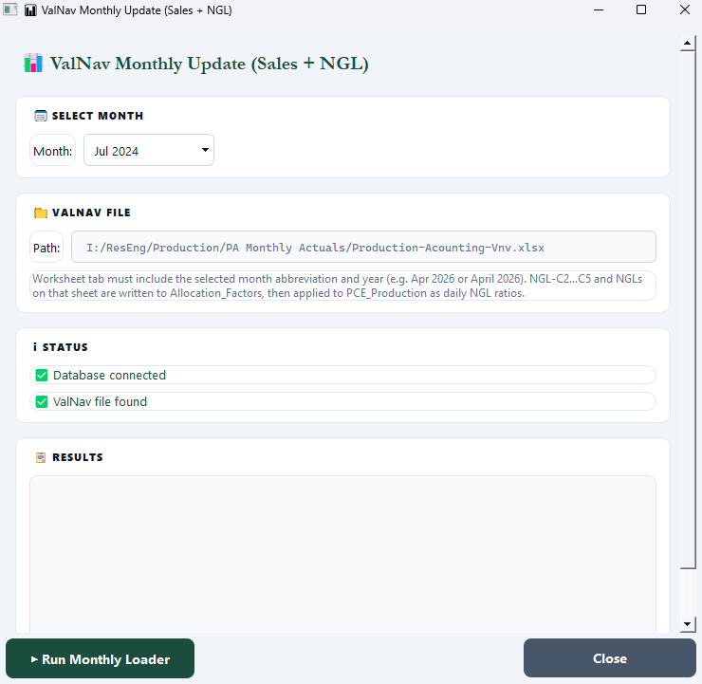

Common Mistakes
- Skipping Prodview first — PA needs current CDA rows
- Assuming PA updates gas sales — that is Public Sales (Accumap)
- ValNav sheet missing NGL columns — NGL ratios are skipped; confirm NGL-C2…C5 and NGLs exist on the month tab

6.4 Public Sales Data and Ratios
Attribute | Detail
When to run | When the Accumap workbook is ready; use From/To months for a range
What changes | Allocation_Factors (Accumap gas sales), PCE_CDA (gas sales, sales CGR), full four-column sales sync on PCE_Production
Typical duration | A few minutes per month in range

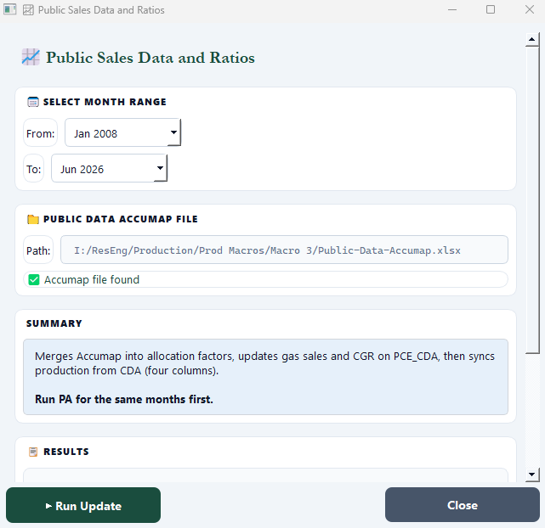

Common Mistakes
- Running before ValNav (PA) for the same months — dialog warns you; condensate-dependent CGR may be wrong
- Cancelling mid-run — completed months stay committed; remaining months are skipped

6.5 Survey Data Import
Attribute | Detail
When to run | New or updated survey Excel/CSV files
What changes | PCE_Surveys (reads PCE_WM for UWI/name matching)
Typical duration | Depends on file size

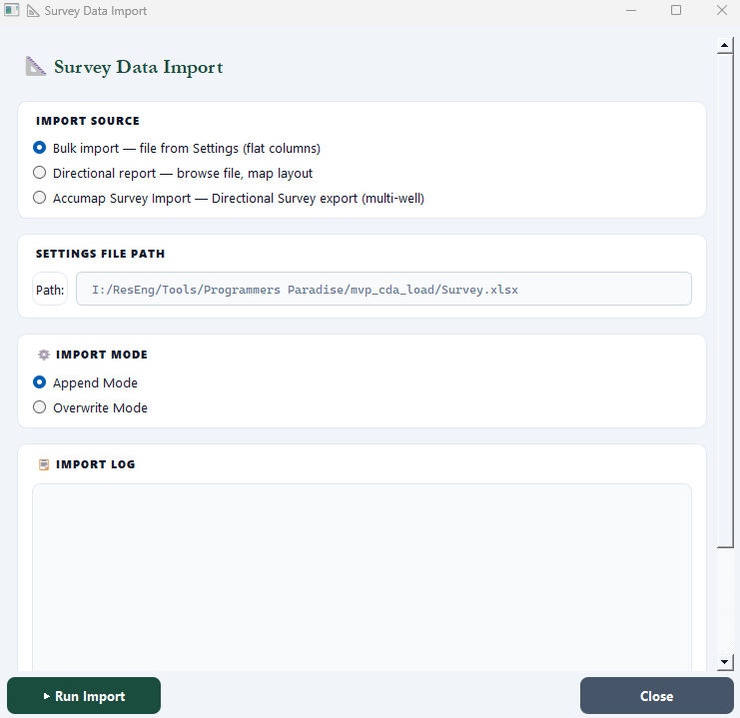

Common Mistakes
- UWIs in the survey file not matching Well Master

6.6 Type Curves Import
Attribute | Detail
When to run | Updated type-curve Excel workbook
What changes | PCE_TC; materialised copy into PCE_Production at import date; PCE_FRCST_PRD rebuild
Modes | Append selected wells from file, or delete selected wells from database

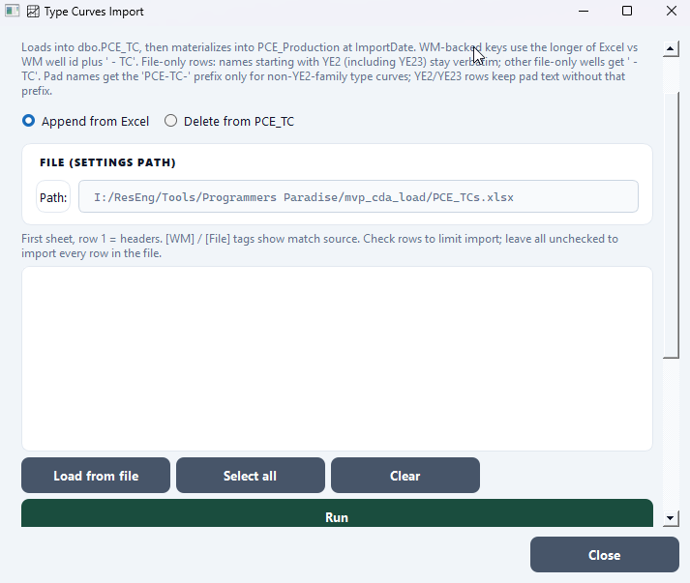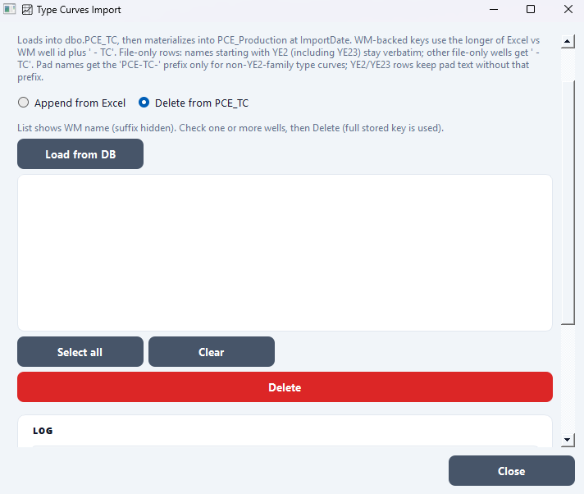

6.7 Monthly Forecasts Import
Attribute | Detail
When to run | New forecast months arrive in the monthly forecasts workbook
What changes | Appends to PCE_Monthly_Forecasts (replaces matching Date+UWI keys from the file); rebuilds PCE_FRCST_PRD
Typical duration | 1–5 minutes

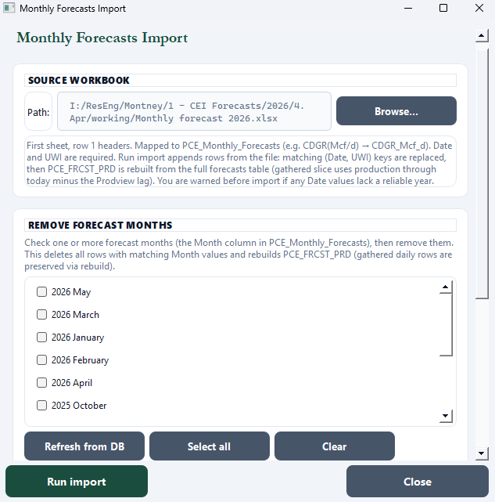

Common Mistakes
- Excel Date cells with no year (e.g. "Apr") — application warns before import; fix the file or confirm to proceed
- Expecting remove-months to delete gathered daily rows in PCE_FRCST_PRD — rebuild preserves gathered production; only the forecast slice is removed

6.8 Whitson+ Mass Upload
Attribute | Detail
When to run | Production or attributes in SQL should be pushed to Whitson+ for modelling
What changes | None in SQL Server — reads PCE_Production and PCE_WM, posts to Whitson+ API

Push Production
Use this when you want to push production data into Whitson+
- Prompts for yes/no before running
- Creates the well in Whitson is not yet there
- Updates all well attributes from Well Master
- Appends daily production (gas, condensate, water, pressures, choke size)

Push Production
Use this when you only want to update well metadata – no production. (Main project is ID 2)
- Opens a popup to pick which attributes to push
- Does NOT create new wells – the well must already be in Whitson+
- Does not push production data

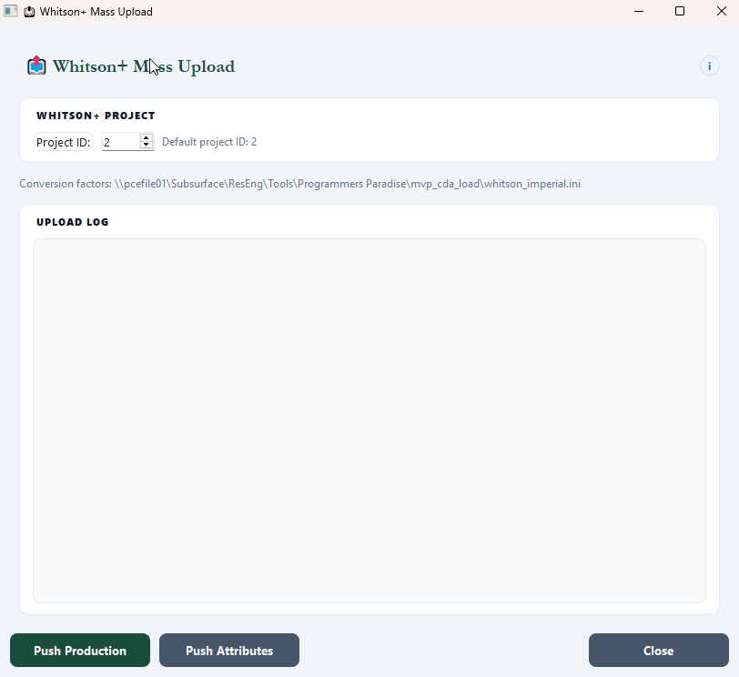

Common Mistakes
- Stale SQL data — run Prodview and monthly loaders first

6.9 Exports / Reports
Attribute | Detail
When to run | Monthly gathered production Excel report is needed
What changes | None in SQL — exports from PCE_Production and PCE_WM to Excel (metric or imperial units)

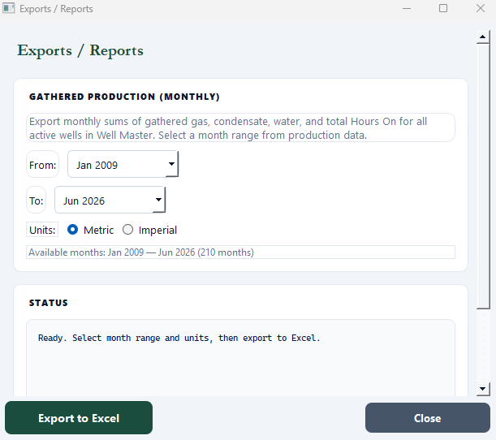

7. Monthly Runbook Checklist
Use this checklist at month-close. Adjust dates to match your process.

- Prodview routine update completed through effective end date (today − 2 days)
- New wells in Well Master have been followed by a Prodview run
- ValNav Monthly Update run for closed month (includes NGL from ValNav sheet)
- Public Sales run for same month(s) after PA
- Monthly Forecasts imported if workbook updated
- Type Curves updated if applicable
- Exports generated if required
- Whitson+ push if reservoir team needs latest data
- Spot-check one well in SQL or export for expected rates and sales columns

8. Troubleshooting
Symptom | What to Try
Password dialog will not accept entry | Confirm with team lead; password is managed internally
SQL connection failed | Check VPN, server name in Settings, Windows auth, ODBC driver
Snowflake / Prodview errors | Check .env credentials, VPN, warehouse availability
Well has no production rows | Confirm well is in PCE_WM with GasIDREC; run Prodview
New well still empty after WM | Run Prodview — Well Master alone does not load production
Public Sales warns missing PA | Run ValNav Monthly Update for the same months first
NGL ratios all zero for month | Re-run ValNav Monthly Update; confirm month tab has NGL-C2…C5 and NGLs columns with data
Forecast import date warnings | Fix Date column in Excel to include full year, or confirm import to proceed
Whitson SSL / certificate errors | Confirm with IT that computer has proper network access
Recent days blank in production | Expected — 2-day Prodview lag; wait or confirm with data team
Broadly wrong history everywhere | Run Prodview full rebuild (or use the CLI: python production_update.py)

9. Glossary
Term | Meaning
UWI | Unique Well Identifier
CDA | Central Data Archive — daily Snowflake-sourced rows in PCE_CDA
Prodview lag | Data loaded only through today minus 2 days
Routine update | Default Prodview mode — Snowflake → CDA + production (~18 months); ~5 min
Full rebuild | Prodview mode — entire CDA history, full Production rebuild
PCE_FRCST_PRD | Combined forecast + gathered table for reporting

Appendix A — Screenshot Checklist
Capture the following screenshots for the Word document and insert them to replace the placeholder boxes. Use the same window size and theme on a production PC; include the full header and footer on the main window screenshot.

# | Screenshot
1 | Password dialog
2 | Main window (header with logo and Credits, RE Production System Actions panel, all nine buttons, Settings in panel header, footer)
3 | Settings dialog
4 | Well Master List (toolbar with Refresh highlighted if documenting composite name sync)
5 | Prodview dialog (routine update mode selected)
6 | ValNav Monthly Update
7 | Public Sales Data and Ratios
8 | Survey Data Import
9 | Type Curves Import
10 | Monthly Forecasts Import (import + remove-months sections)
11 | Exports / Reports
12 | Whitson+ Mass Upload

Appendix B — Building the Windows Executable (IT)
For packaging only — operators normally use the deployed .exe.
- Use 64-bit Python on a build PC in VSCode or a terminal
- pip install -r requirements.txt and pip install -r requirements-dev.txt
- pyinstaller --clean "PCE_RE_Production_Update V2.4.spec"
- Ship the entire dist/PCE_RE_Production_Update VX.X/ folder including:
  - _internal/
  - PCE_RE_Production_Update VX.X.exe
  - images/
  - settings.ini (include [WHITSON] API credentials)
  - whitson_imperial.ini
  - survey_mapping_presets.json
  - .env (Snowflake credentials; configure per deployment PC)

